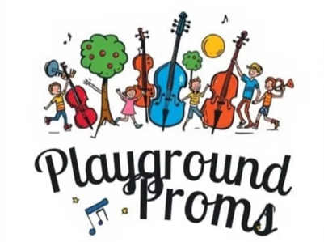

The Instrument and Me – Lyric Sheet

Verse

This instrument
Once was a seed
Grew in the ground
Into a tree

With careful fingers
And clever ears
This piece of nature
Is ours to hear!

Chorus

The body’s made of wood
There’s some sparkle from a pearl
The strings are aluminium
Very tightly curled

All the gifts of nature sound
In perfect harmony around
Nature’s in the instrument and me!

Outro

The instrument and me
The instrument and me
The instrument and me
The instrument and me!

